**Tiger Team Status Meeting 20190820**

**1:00 -1:30 EST**

**Attendees:**

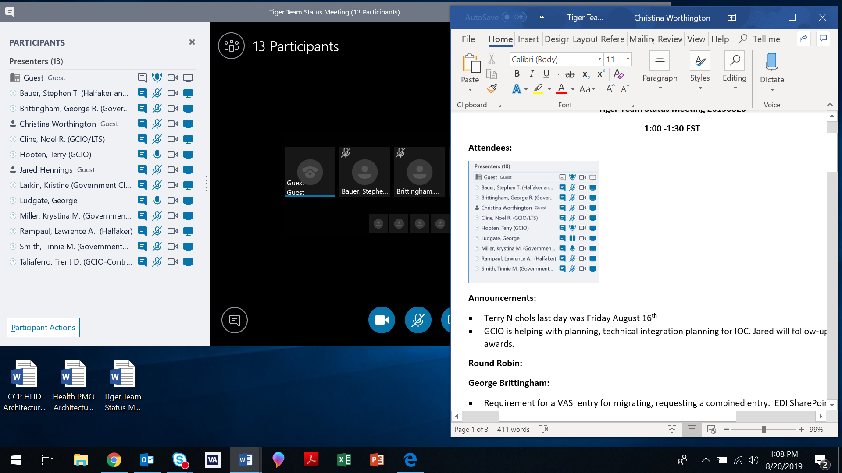

**Announcements:**

* Terry Nichols last day was Friday August 16th, actively looking to fill Terry’s role.
* GCIO awarded EHRM support, Chris Ditter’s group is helping with planning, technical integration planning for March IOC.
* Jared will follow-up on GCIO awards
* Noel stated updated PLM documentation is located on SharePoint.

**SharePoint Overview:**

* Noel provided current status of SharePoint:

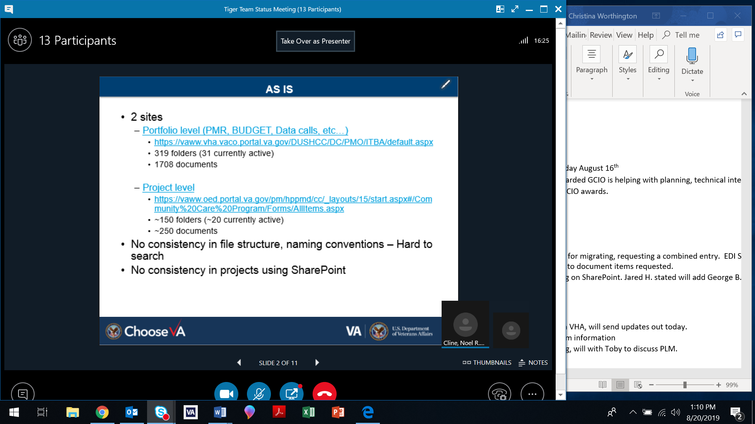

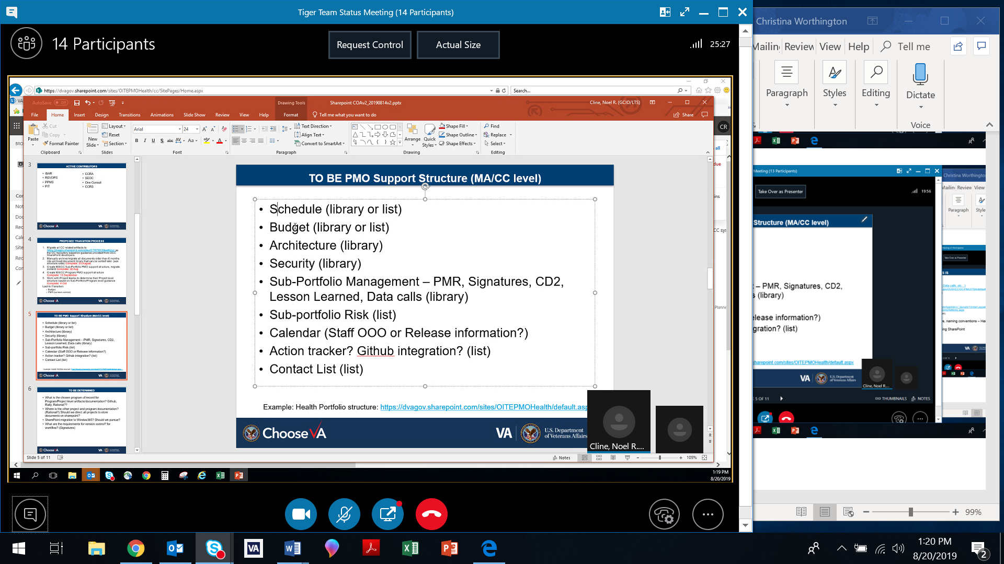

Proposed Transition Process:

* Migrate all CC related artifacts to CC repository based on guidance provided from OCC SharePoint developers
* Manually archive/migrate documentation older than 6 months into archived document library
* Create MA/CC Sub-Portfolio PMO support structure
* Create MA/CC Program PMO support structure
* Work with Project teams to determine Project level structure based on Sub-Portfolio/Program structure